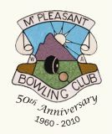
Invites you to their
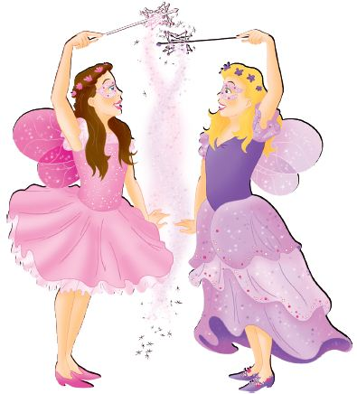

MT PLEASANT BOWLING CLUB (INC.)
LADIES DIVISION

CHRISTMAS GALA DAY
Friday 5th December 2014
PRIZE POOL $1,100
Based on minimum of 30 teams
2 games x 13 ends

Sponsored by
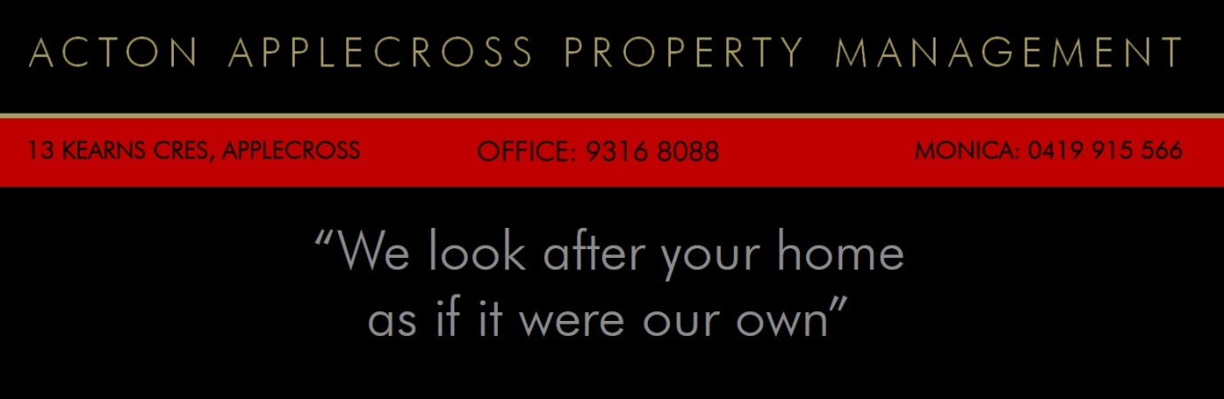

Arrival 9.30am — on the green 10.00am
$60 per team (inc. GST)
Lunch included

Fantastic stalls & great raffles
Gifts for everyone
For further information contact:
Anne on 9364 6476 or Colette on 9332 0393 / 0416876262
lmatch@mtpbc.org.au
www.mtpbc.org.au
Join us for a great day



Entries close Friday 28th November 2014
……………………………………………………………………………………………………………………………………………………………………………..
CHRISTMAS GALA DAY
Please post this nomination form with your cheque to:
The Secretary
Mt Pleasant Bowling Club – Ladies Division
Bedford Road, Ardross, WA, 6153

Club…………………………………………………… Contact ph. no./email ………………………………
Skipper………………………………………………. Third ………………………………………...……………
Second ………………………………………………. Lead ………………………………………………………..

