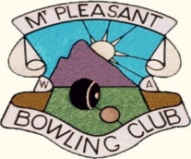

Mt. Pleasant Bowling Club - Roll-ups.

29th April 2020

To all bowing members.

We now have the go ahead to have roll-ups up to a maximum of 10 people, effective from today.

The Executive supports the Club greens being open based on the following conditions;

1. Maximum of 10 people only.

2. Initially on C green only - A green available from next week.

3. Jacks and mats will be located outside the umpire / bowls room.

4. No access to clubrooms & toilets.

5. Bookings must be made to Terry Ridley (0405 360 067) to secure a 2 hour window for a roll-up. This will ensure the total numbers of bowlers on site will not exceed 10 people at any time.

Time Slots 1. 8.00am - 10.00am
2. 10.30am - 12.30 pm
3. 1.00pm - 3.00 pm
4. 3.30pm - 5.30 pm

6. Access to site via Bedford road gate - code 1960.

7. Only 4 players to a rink.

8. Distance separation must be observed at all times.

9. Hand sanitiser will be available and members are to be encouraged to use before and after the roll-up..

10. Note: Club members are asked to adhere to the above policy as failure to do so may lead to access being denied.

Enjoy your roll-ups.

Club Executive

